Current Issues in Sport Science

Insert the title here (without upper case letters)
Abstract
Please insert an abstract/maximum word count: 300
(for a main article or author’s response of a target article, maximum word count: 200)
(for an editorial or a commentary on a target article, maximum word count: 140)
Keywords
Please insert about 5 keywords (not restricted by guidelines)/maximum: 8 keywords
Article type
Please choose between “original article”, “review article”, “report” (including case studies, short communications, theoretical or practical reflections), or “commentary” (in case of a commentary on a target article).

Introduction
Please insert the main text body here. The text should be written either in British English or in American English.
For original articles, review articles, and reports (including case studies, short communications, theoretical or practical reflections), the maximum word count is 5,000, and for a commentary on a target article 1,400. Please note that this maximum refers to the word count for the main text body only, that means, excluding the title page, abstract, keywords, article specifications, references, figures and tables (including captions). Special maxima will be specified for invited articles.
Do not insert a blank line between paragraphs.

Tables and figures
Please insert a blank line before and after a figure or table as follows.

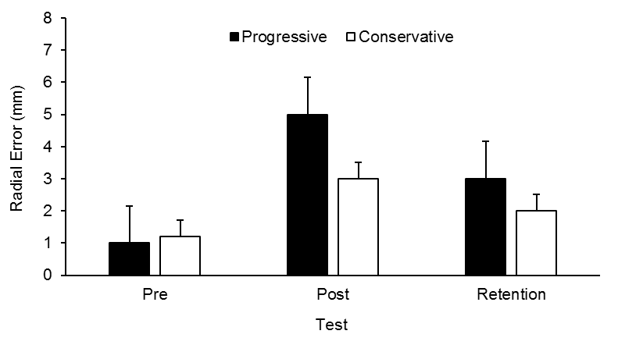
Figure 1. Radial Error (mm) in pretest, posttest and retention test as a function of treatment (progressive vs. conservative). Flankers indicate S.E.

Include your tables and figures in the document. Please note the following:
Figures and tables need to strictly adhere to the guidelines specified in the APA manual. Please note that manuscripts with figures or tables that seriously violate APA style will be sent back to the authors by the Editor-in-chief before considering them for publication.
Contrary to APA style, CISS prefers figure and table captions not as headings (with upper case letters) such that lower case letters should be used for figure as well as for table captions.
In original articles, review articles, and reports (including case studies, short communications, theoretical or practical reflections), a maximum of eight figures or tables in total must not be exceeded (i.e., for example, five figures and three tables).
No more than one single figure or table is accepted for a commentary on a target article; in those cases, the maximum word count needs to be reduced accordingly.
As figures need to be submitted in a resolution that suffices publication requirements, you are required to submit the original files in the copyediting stage at latest. Nevertheless, please also insert a copy of the figure in the article.

Table 1. Table title.
Column 1 | Column 2 | Column 3 | Column 4 | Column 5 | Column 6
1 | 2 | 3 | 4 | 5 | 6
1 | 2 | 3 | 4 | 5 | 6
1 | 2 | 3 | 4 | 5 | 6
1 | 2 | 3 | 4 | 5 | 6
1 | 2 | 3 | 4 | 5 | 6
1 | 2 | 3 | 4 | 5 | 6
1 | 2 | 3 | 4 | 5 | 6

If possible, do not use footnotes but try to include the crucial information in the main text. For all details on style, referencing etc., please see the APA manual. Please note that manuscripts that do not adhere to APA style will be sent back to the authors by the Editor-in-chief before considering them for publication.

Methods
The text may be structured into sections as it seems most appropriate to the authors. However, in cases of articles presenting original research, the following sections would be preferred: Introduction, Methods, Results, Discussion (and maybe completed by Conclusion). If more than a single experiment is reported, an appropriate structure would be: Introduction, Experiment 1, Experiment 2, General Discussion (and maybe completed by Conclusion). Use the format “Überschrift1/Heading 1” for first-level subheadings (without a blank line before and after the subheading as “Methods” before this paragraph).

Participants
For second-level subheadings the format “Überschrift2/Heading 2” should be used (without a blank line before and after the subheading as “Participants” before this paragraph). In cases of articles presenting original research, the following second-level subheadings would be preferred: Participants, Apparatus, Procedure, Measures (or similar). If more than a single experiment is reported, these subheadings should appear on the third level as follows.

This is a third-level subheading
For third-level subheadings please use the format “Überschrift 3/Heading 3” (as “This is a third-level subheading”, without a blank line before the subheading). Please use third-level subheadings as sparely as possible. Refrain from using fourth-level subheadings.

Apparatus
For numbered lists please use the following format:
- A number list item
- A number list item
- A number list item
- A number list item

Procedure
For bullet lists please use the following format (“Aufzählungzeichen/Bullet list”):
- A bullet list item
- A bullet list item
- A bullet list item
- A bullet list item

Measures
text text text text text text text text text text text text text text text text text text text text text text text text text text text text text text text text text text text text text text text text text text text text text text text text text text text text text text text text text text text text text text text text text text text text text text text text text text text text text text text text text text text text text text text text text text text text text text text text text text text text text text text text text text text text text text text
For block quotations please use the following format:
Block quotation block quotation block quotation block quotation block quotation block quotation block quotation block quotation block quotation block quotation block quotation block quotation block quotation block quotation block quotation block quotation block quotation

Results
text text text text text text text text text text text text text text text text text text text text text text text text text text text text text text text text text text text text text text text text text text text text text text text text text text text text text text text text text text text text text text text text text text text text text text text text text text text text text text text text text

Discussion
text text text text text text text text text text text text text text text text text text text text text text text text text text text text text text text text text text text text text text text text text text text text text text text text text text text text text text text text text text text text text text text text text text text text text text text text text text text text text text text text text

References
American Psychological Association. (2020). Publication manual of the American Psychological Association. The official guide to APA style (7th ed.). American Psychological Association.
Please note that manuscripts with a reference list that does not adhere to the latest APA style, i.e. 7th edition, will be sent back to the authors by the editorial team before considering them for publication. For electronic resources, the doi is needed as follows:
Kohake, K., & Heemsoth, T. (2021). Need support, need satisfaction and types of motivation in Physical Education for children aged 8 to 13. Development and preliminary validation of the German SMoPE-instrument. Current Issues in Sport Science (CISS), 6, Article 005. https://doi.org/10.36950/2021ciss005

This is a footnote in the correct format.

